Year 1 Home Learning Matrix Spring 1
Please see the suggested activities below for you to complete with your child at your leisure. Children are welcome to bring in completed homework at any time.
Science  Create a poster on how to look after a pet. What type of animal is it? What does it need? | Geography  Take photographs of different human and physical features in your local area.  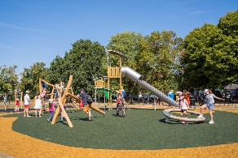
Maths  Can you represent all of your numbers to 20 and then write the corresponding numbers in words? E.g. 1 – One, 2 – Two, 3 – Three. These spellings are part of the Year 1 Curriculum. | Handwriting  Using the handwriting paper provided, practise writing the following tricky words on the handwriting lines.  because could  people would  water should  there where
English  We are learning all about Dragons! Can you think of another mythical creature and create a story for it? Don’t forget to include, finger spaces, careful sounding out, capital letters, full stops and adjectives. | PSHE  Think about what you are responsible for at home. Do you have any chores? You could draw and picture and write a sentence about them.  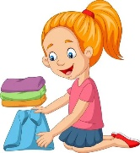
Music  Can you make a musical instrument from things found in your home? E.g. Rice/pasta shaker.  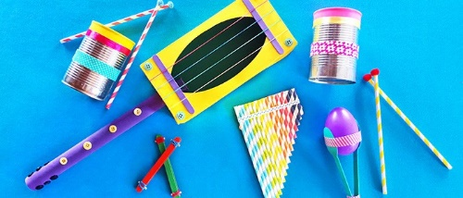 | RE  Can you think of any good deeds that you could perform around your house? Who might like some help? Who might want you to play with them? Is your bedroom tidy?

