Phonics |  | English |  | Maths
Children will continue to learn Phase 5 alternative sounds. Each week you will see exactly which sounds the children are learning on the phonics sheet emailed with the weekly objectives. We will also send out weekly spellings. |  | Through Talk for Writing we will focus on story writing using ‘Zog’ by Julia Donaldson. We will then move onto character descriptions and create our own dragons to describe. |  | Children will be building on their knowledge of place value to 20 and addition and subtraction to 20,
Science | RE |  | Geography/History |  | Art and DT
Our Topic is The Human Body, where we will focus on the 5 senses. Please see the knowledge organiser below. | Children will be learning Why Jewish families celebrate the gift of Shabbat. Please see knowledge organiser below. |  | Our topic is called ‘The UK’. Children will learn all about the location and characteristics of the countries which make up the United Kingdom. Please see the knowledge organiser below. |  | Our Art topic this half term is Architecture. The children will be drawing prominent buildings and learning the skills to be an architect. Please see knowledge organiser below.
Music | PSHE |  | PE |  | Computing
This Term we are ‘Exploring Sounds’. | Children will explore how to keep themselves safe, what their rights are and how to be respectful. |  | The children will be learning how to play netball and dance, and learning all of the skills needed to be successful. |  | We will continue to teach our computing lessons through our iPads. Our topic is ‘Grouping Data’.

Science Knowledge Organiser
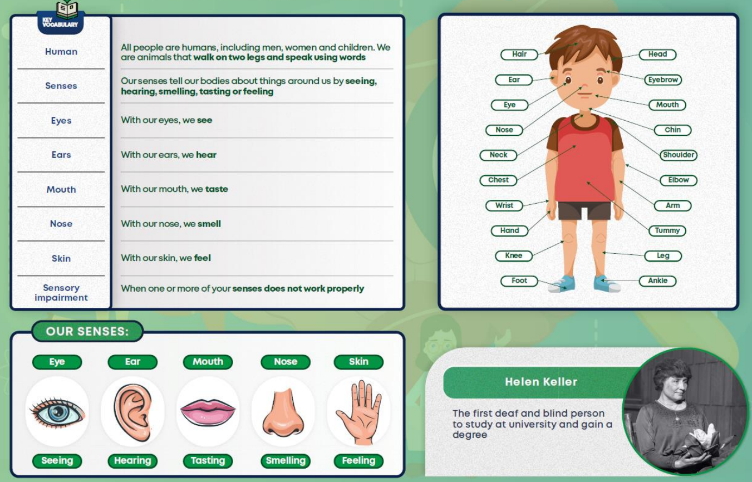
Geography Knowledge Organiser
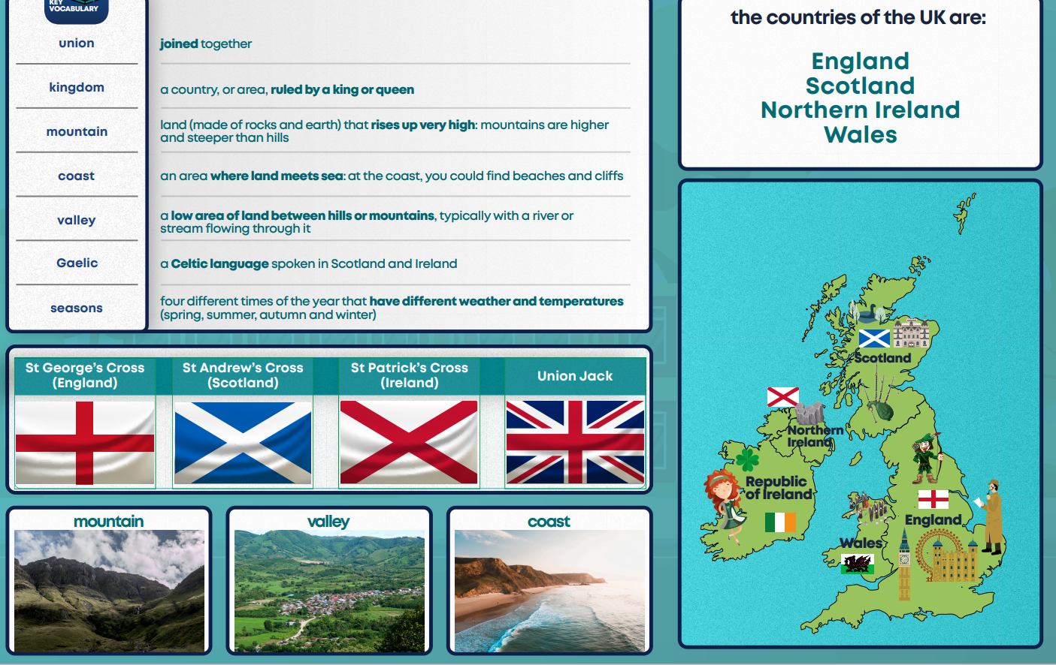

Art Knowledge Organiser
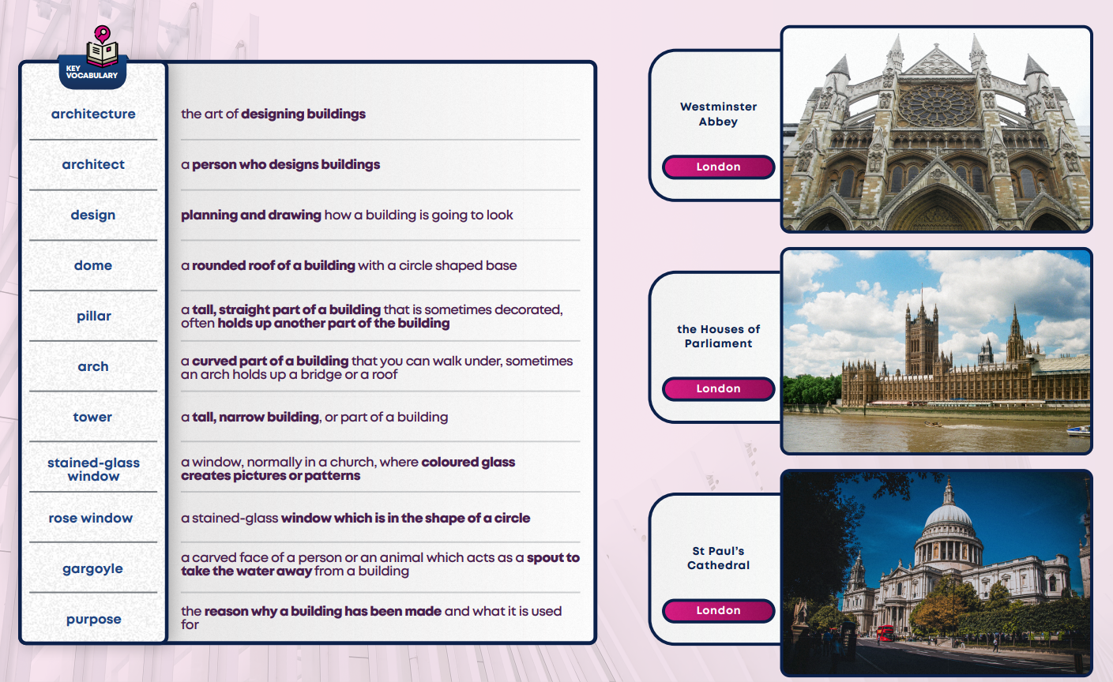

RE Knowledge Organiser
