Year 1 Home Learning Matrix Summer 1
Science  Go outside and search for signs of Spring. You could take photos, collect items or create a collage or poster to represent Spring.  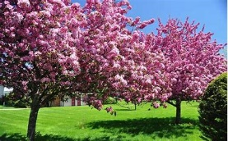  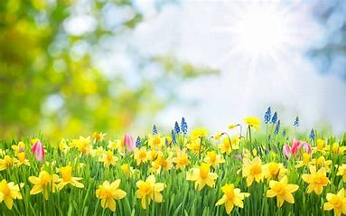 | Geography  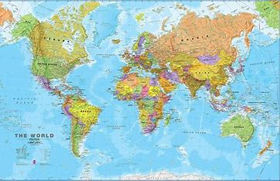  Choose a country to research and make a project about. Look at the continent the country belongs to and nearby oceans. You could look at photos of the different landscapes within the country, landmarks and interesting facts. You can present it however you wish but it could be a poster or booklet.
Maths  Use tens frames and number lines to practise addition and subtraction to 50.  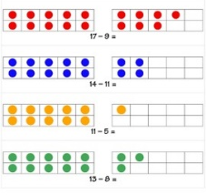  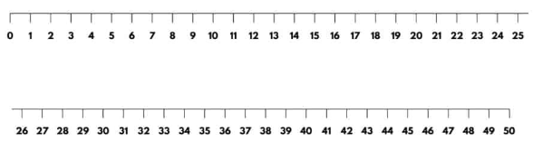 | Handwriting  Using the handwriting paper provided, practise joining the following digraphs/trigraphs:  ch nn er  sh mm ai  th dd ee  ng ll ar  ss ck ur  tt bb ear  pp nk air
English  We are learning about recounts. Can you keep a diary and write all about your day/weekend?  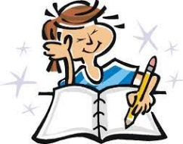 | PSHE  Create your own Eat well plate. Think about the types of food that can go into each section.  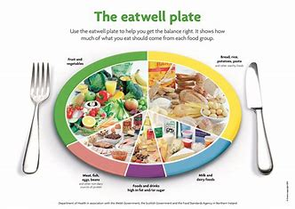
Music  Choose some songs to listen to. Can you clap along to the beat of the song? Can you find a song where the beat is slower? Can you find a song where the beat is faster?  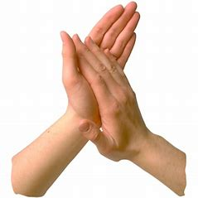 | RE  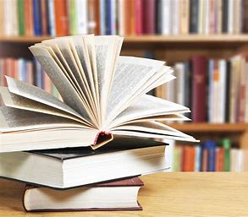  We are learning about the Torah which is special to Jews. Can you find out about the special books in other religions? What are they called? What books are special to you?
Please see the suggested activities below for you to complete with your child at your leisure. Children are welcome to bring in completed homework at any time.

