|  |  |  |  |  |  |
| --- | --- | --- | --- | --- | --- |
| Phonics/Reading | | English | | Maths | |
| In phonics we will be re-capping the phase 5 sounds and beginning to teach specific spelling rules such as prefixes and suffixes.  Guided reading sessions for the fluency books will continue to happen three times per week.  Those on Little Wandle books will still have two reads a week focusing on decoding, intonation (prosody) and comprehension. The children can also choose a colour band book to take home for reading for pleasure.  During guided reading sessions, we will focus on answering questions about a text using these skills: vocabulary, inference, prediction, explain, retrieval and summarising. | | Throughout this half term we will be writing two texts the first one focused on instructional writing. We will be exploring what an instructional piece of text needs for example command words. We will also be focusing on the use of suffixes and expanded noun phrases. We also want to encourage the children to use the conjunction ‘because’ in all their works. After writing our own instructional text will be writing their own stories based off a book called Traction Man. Throughout this term we will be focusing on the key skills required for Year 2 such as subordinating conjunctions and making sure everything is in a consistent tense. | | At the beginning of term, we will be focusing on fractions. We start by recapping equal and unequal parts before finding and recognising a half, a quarter, a third. We will then challenge the children to recognise the equivalence of a half and two-quarters as well as introducing unit and non-unit fractions.  At the end of term, we will be learning to tell the time. Children will be able to tell the time to O’clock, half past, quarter past and quarter to as well as to 5 minutes. | |
| Science | RE | | Geography/History | | DT |
| In Science this half-term we will be looking at plants. We will start the unit by conducting an experiment. We will be studying plants and what they need to grow. We will compare a plant that is in the dark and in the light and one that is watered and one that is not. We will then look at what plants are farmed and how they are kept in the correct conditions. | This half-term we will be exploring the religion of Islam. Throughout the weeks we will be discussing how their prayer differs from ours. We will have the opportunity to look at a prayer mat and watch a prayer service. We will also discuss why God has 99 names in Islam and what they all mean. | | Each half-term we will alternate between a Geography unit and a History unit.  This half-term will be focused on ‘Romans in Britain’. This unit will provide children with an early understanding of the Roman Empire and the Roman invasion of Britain. We will discuss the significant individuals Julius Caesar, Emperor Claudius. | | For DT this term, we will be making our own pizzas. We will be measuring and mixing ingredients to make pizza dough and we will be adding our choice of toppings. |
| Music | PSHE | | PE | | Computing |
| This term in music we will be continuing with charanga lessons. Alongside this we will be starting to rehearse for the End of year play. When this happens please help your children with their lines and songs. | This half-term we are going to be talking about how to be our best selves. Throughout this unit we will discussing what foods keep us healthy, how we can make good choices and thinking about how we can practice and improve. We will also be looking at the organs in the human body and how we keep them all healthy. | | This term we will be focused on tennis and athletics. Throughout these lessons we will be looking at how to hold a racket, throwing and catching and playing small mini games. We will also be partaking in different athletics activities. | | This half-term we are going to be looking at making music on the iPads. We will be using the app garage band to do this. We will have a go at creating music on different instruments and then layering them together. |

Science – plants

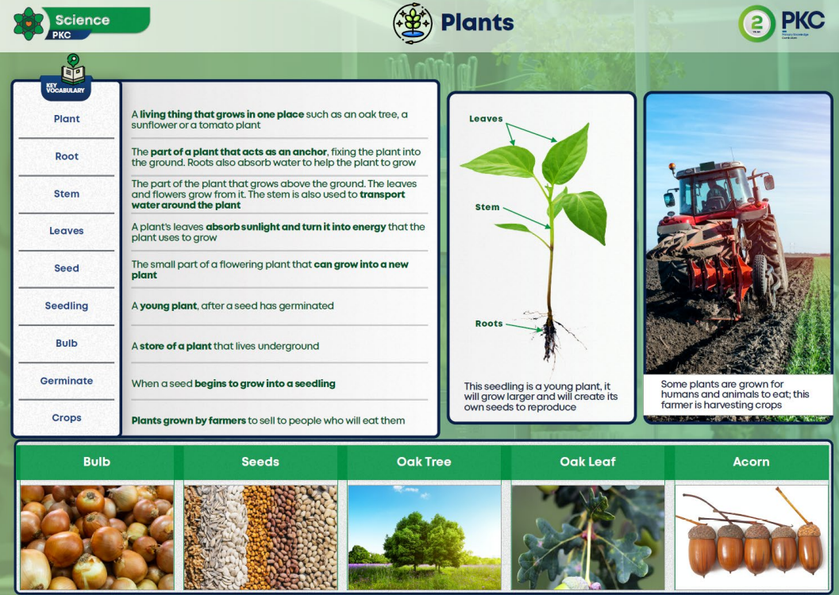

History – The Romans

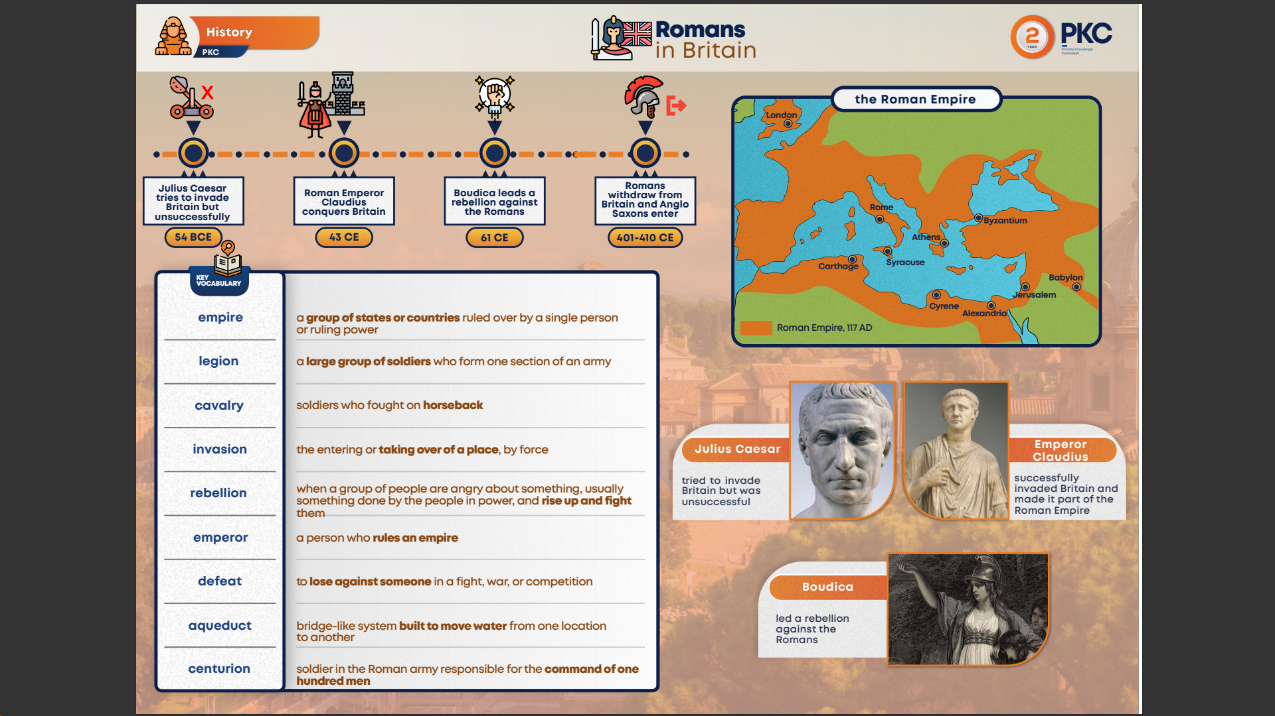

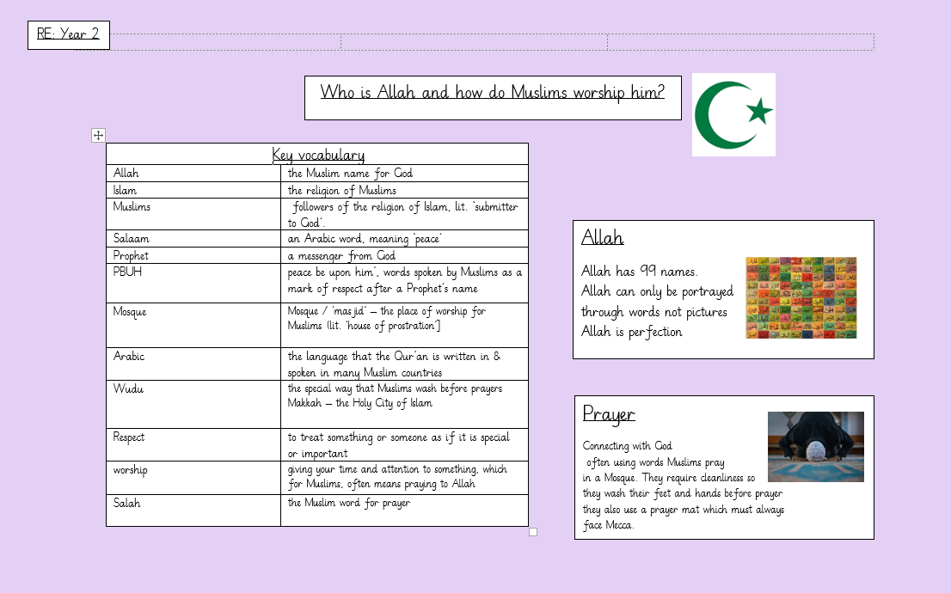

RE