|  |  |  |  |  |  |
| --- | --- | --- | --- | --- | --- |
| Phonics/Spelling/Reading | | English | | Maths | |
| In phonics we will be re-capping the phase 5 sounds and beginning to teach specific spelling rules such as prefixes and suffixes.  Those on Little Wandle books will have three reads per week focusing on decoding, prosody and comprehension. The children that are on fluency books will have three reads per week focusing on a chapter of the book. Each session consists of a pre-read, prosody and comprehension  Children on Phase 5 and above will continue to take colour book bands home to promote reading for pleasure. Please remind your child to change their books as although they are reminded, this is not monitored by staff.  During guided reading sessions, we will be focusing on written comprehension and answering questions about the different texts. | | This half term will be focused on writing a setting description and a non-chronological report. We will be using Beyond the Tunnel to help us the visualise our own setting.  We will be learning the text together in oral form, drawing a text map and acting the text out.  Before the children adapt the text and produce their own piece of writing we will be annotating key features of a variety of setting descriptions and instructions as well as focusing on a SPaG topics such as; simple past tense and time connectives.  We will be producing information booklets about animals using iPads to research interesting facts and sharing our completed projects with other year groups. | | At the beginning of term, we will be focusing on money. This will include how many pennies in a pound and different ways we can make a pound. We will also add amounts together and work out how much change we will get.  After this we will be looking at multiplication this is taught through small steps. We start with looking at equal groups then to repeated addition and finally applying it to a multiplication number sentence.  We will continue using a step-by-step process using concrete resources (things you can touch) pictorial (pictures) and then applying this to abstract representations e.g numerals and number sentences. | |
| Science | RE | | Geography/History | | Art and DT |
| In Science this half-term we will be looking at materials and their properties. We will explore different materials and the reason behind using different materials for certain objects. We will look at the particles in a solid liquid and gas as well as exploring microscopes. We will look at the creator of Velcro and find out about his story of how he discovered the sticking properties. | This half-term we will be exploring who Allah is and how Muslims worship him. We will be researching what is important to Muslim families. We will look particularly at the qu’ran and why it is so important to them. | | This half-term we are building on from the Y1 Kings, Queens and leaders’ unit with the aim to deepen the pupils’ knowledge of how Britain was ruled in the past.  Our unit is the Tudors, focusing on the lives of Henry VIII and his three children. We will discuss monarchy, power and religion as well as study sources to find information about the English Reformation and the ‘Golden Age’. | | DT day will take place in Spring 2 and details will be announced nearer the time.  In Art we are introducing the children to landscape paintings. We will be studying and comparing paintings by Turner and Constable. We will be creating our own seascapes showing the rough and stormy seas through a variety of bold brushstrokes. The last lesson of this unit focuses on the effect of symmetry in art and producing symmetrically balanced sketches. |
| Music | PSHE | | PE | | Computing |
| This term in music we will be continuing with charanga lessons. The focus will be inventing our own musical stories and we will be doing this using recorders. We will be learning the notes G, B, C, A. | This half-term we are going to be talking about how we keep safe. This includes how to identify things that upset us. We will also be talking about positive and negative touches and who we can contact if we feel uncomfortable. | | This term we are focusing on invasion games in netball. During this we will concentrate on effective teamwork skills as well the technical side of netball, how to pass and make sure your teammate is ready to catch.  We will also have a focus on dance this half term. This will be an indoor PE session where children will develop their balance. | | This half-term we are going to be looking at instructional algorithms.  This links to the instructional writing we will be doing in English. We will be using the iPads to create algorithms as well as having a go at using the Beebots! |

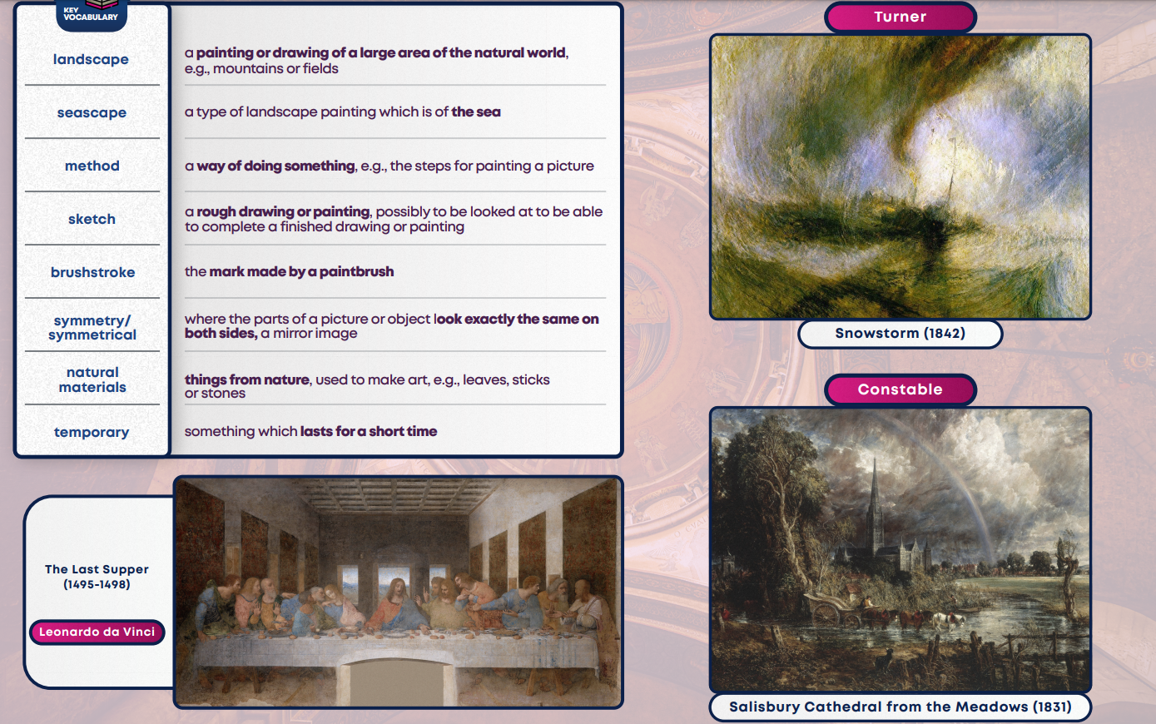

Art – landscapes and symmetry

Science – materials and matter

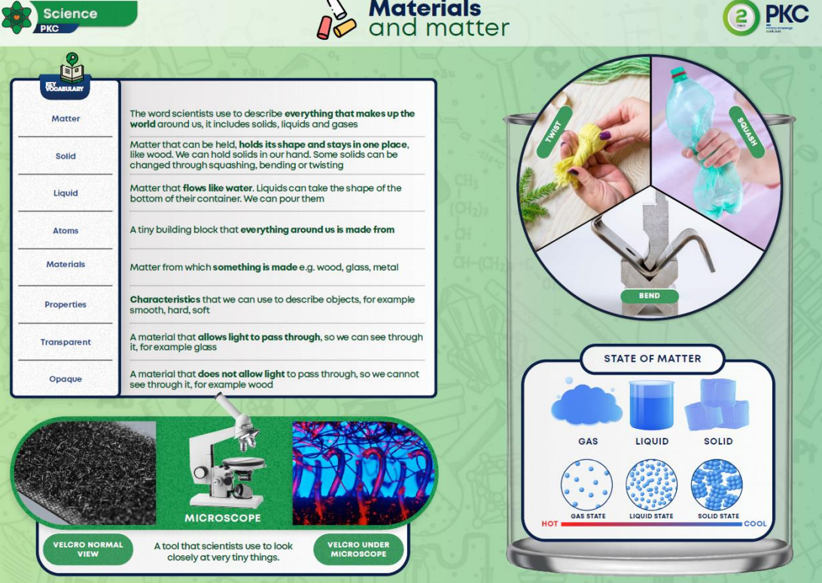

History – The Tudors

