|  |  |  |  |  |  |
| --- | --- | --- | --- | --- | --- |
| Spelling/Reading | | English | | Maths | |
| We will be continuing with daily spelling lessons. These are taught in units so the children feel confident to use the newly learnt rules in all their writing across the curriculum (see below for the half-termly overview). Each lesson reviews previously learnt sounds, spellings and tricky words as well teaching new common spelling rules, homophones and common misspellings.  Guided reading sessions for the fluency books will happen three times per week.  Those on Little Wandle books will still have two reads a week focusing on decoding, intonation (prosody) and comprehension. The children can also choose a colour band book to take home for reading for pleasure. | | We will be focusing our writing from texts based on our Space topic.  Our focus over the first three week will be to write a five-part story using more complex vocabulary with a focus on adverbs, similes and the use of apostrophes.  The last three weeks will be based on a non-fiction text ‘Holiday to the Moon’ we will be writing persuasive adverts using headings, statements and lists also how we can use various sentence openers, sentence lengths and prepositions. | | We will begin Spring 2 with a new topic, measure and length followed by mass and weight. Throughout these topics we will be practically measuring different objects as well as theorising how heavy something might be. We will be measuring in m, ml, g and kg.  As well as the above we will continue to practice the 2s, 3s, 5s and 10s timetables. | |
| Science | RE | | Geography/History | | Art and DT |
| This half term we will be learning about space. We will learn about our solar system and qualities of each of the planets. We will be learning about the rotation and orbit of Earth and the moon. We will touch upon constellations and discuss why planets and constellations are named after Greek and roman Gods. We will also talk about the 1969 trip to the moon! Through this topic we will be visiting Winchester Science Museum which we are really excited about! | Throughout this half term we will be learning about the topic ‘Why is Jesus the saviour?’. We will look at the Easter story and how Jesus’s sacrifices saved us. We will be linking this to hero’s today such as doctors, policemen and soldiers. We will also discuss the story of Zacchaeus and how it show us the Jesus is forgiving and does not exclude anyone. | | Our Geography lessons this half term are all about The British Isles. Children will be able to name locations on a map, to answer geographical questions such as ‘what is it like to live in this place?’.  Throughout this unit children will also look at the link between the geography of a place and its human features. We will study a small area of a non-European country and compare this location with a small area of the United Kingdom. | | We are learning about History Painting, a term used to describe painting which shows stories from classical history, mythology and the Bible. We will be studying in detail art which tells the story of Theseus and the Minotaur. We will explore how artists can show different characteristics or personalities by the way they draw. We will be making a detailed studies and mixed media pieces based on this. |
| Music | PSHE | | PE | | Computing |
| This term in music, Badgers will be learning the notes B, A, G, C on the recorders and will have an introduction into musical staff notation. They will look at orchestral families and instruments within these families. Foxes will be using notes, C,D,E,F,G,A on glockenspiels with music backing track. They will be looking at musical structure and beginning to compose simple music as a group and individually. | This half-term we are going to be talking about how we do our best in school. We will discuss an ideal classroom and what we can do to ensure that we are creating one. We will be discussing what it means to be responsible with money and why it is important not to litter. | | In PE this half term we will be learning how to play netball. We will be learning about different types of passes and how we move across a pitch. Gymnastics will be learning further shapes and adding levels of difficulty into making their own routines. | | Throughout this half term we will be using the iPads to create charts these will be in form of pictograms and tally charts. We will be comparing how we get to school, our favourite colours and our favourite subjects. |

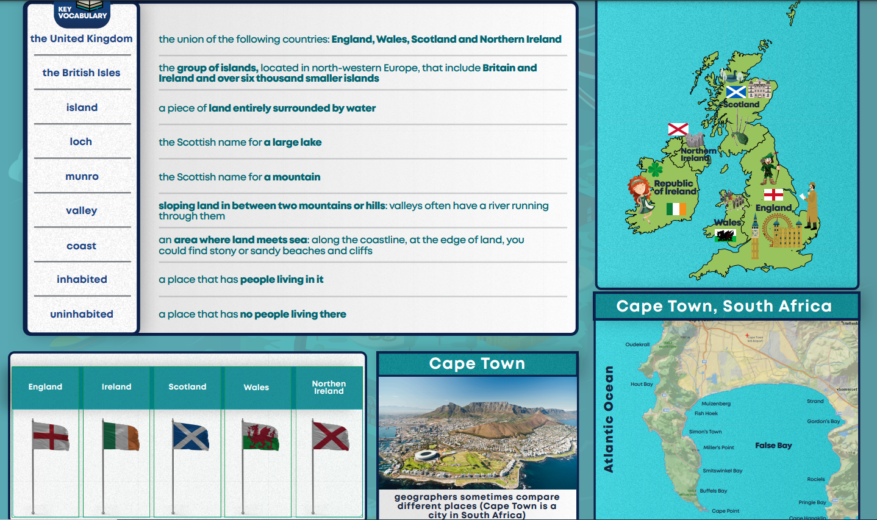

Geography – The British Isles

Art – History Painting

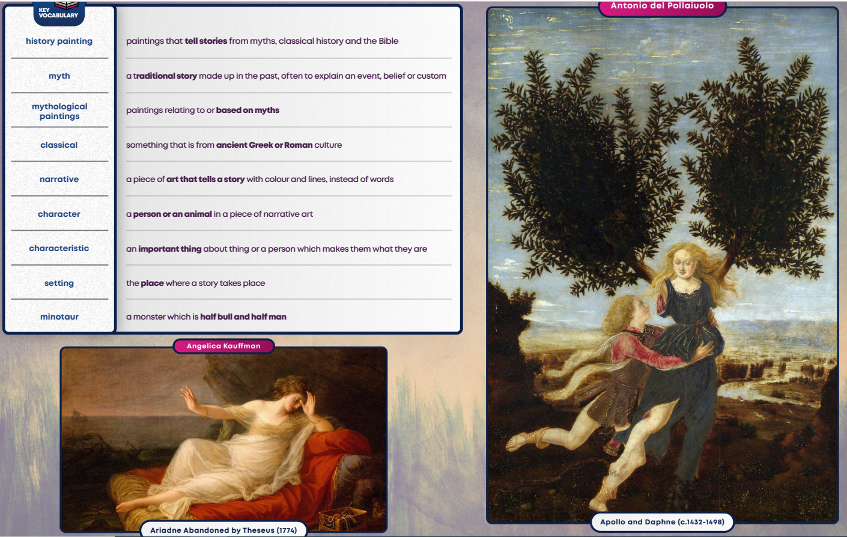

Science – Astronomy

