Phonics |  | English |  | Maths
Children will review Phase 3 and Phase 4 (long vowel sounds) and move onto Phase 5 sounds. Each week you will see exactly which sounds your child is learning on our phonics sheet, which is posted on the Valley End website. |  | Through Talk for Writing we will learn how to write characters descriptions featured in the story of Little Red Riding Hood. We will then learn the story and adapt it to write our own fairy tale. |  | Children will be building on their knowledge of place value, addition and subtraction. We will be using tens frames and part-whole models to support their understanding of this.
Science | RE |  | Geography |  | Art
On our investigation table the children will have the opportunity to explore and discuss the world around them. | Children will be exploring the big question…Why do Christians call God ‘Creator’? |  | Our topic is called ‘Spatial Sense’. Children will learn all about aerial views and map reading. Please see the knowledge organiser below. |  | The children are learning all about ‘Colour’. Including why the primary colours are important. Please see the knowledge organiser below.
Music | PSHE |  | PE |  | Computing
This term we are using the Charanga programme to teach music lessons. We will be recognising the beat within different songs. | Children will explore themselves, their feelings and their relationships with others. They will also be taught about the Zones of Regulation and how we use the zones to regulate our emotions. |  | The children will be learning how to play invasion ball games and learning all of the skills needed to be successful in these games. |  | We will teach the children how to logon to their individual iPad profile, and how to navigate different apps. We will also be learning about technology around us
Art Knowledge Organiser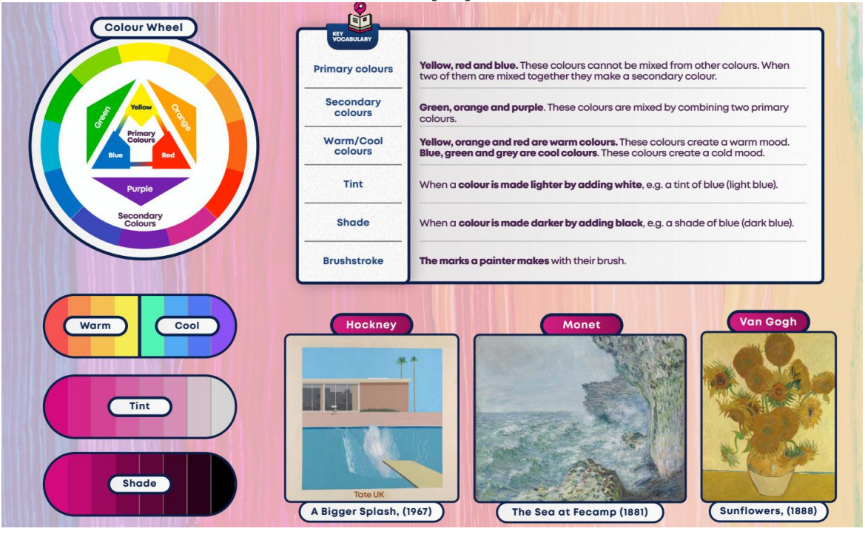
Geography Knowledge Organiser
