Phonics |  | English |  | Maths
Children will recap the sounds required in their Phonics Screening Check. Each week you will see exactly which sounds the children are learning on the phonics sheet emailed with the weekly objectives. |  | We will be learning how to write a recount, exploring using the past tense, time adverbials, prepositions, and including our own opinion. The children will focus this learning towards writing a recount of their trip to Nower Wood. Children will also learn about writing instructions, using the duck eggs as our catalyst. |  | We will be introducing children to multiplication, division and fractions. Children will be learning to count in 2s,5s and 10s. They will recognise and find half and quarters of an object, shape and quantity.
Science | Geography |  | RE |  | Art
Our Topic is ‘Seasons and Weather’. Children will learn about the four seasons and know that tools are used to gather data about the weather. Please see the knowledge organiser below. | Our topic is called ‘The Seven Continents’. Children will learn all about the seven continents and five oceans. They will understand the Equator is an imaginary line around the middle of the Earth. Please see the knowledge organiser below. |  | Our topic is ‘What is the Torah and why is it important to Jewish people?’. We will explore what the Torah looks like, what it includes, and where it is kept, helping children to learn the reasons why the Torah is so special. Please see the knowledge organiser below. |  | Our art topic is ‘Sculpture’, where the children will be exploring 3D art, moulding and casting. Please see the knowledge organiser below.
Music | PSHE |  | PE |  | Computing
We will continue to use the Charanga programme to teach music lessons. We will learn about songs to help us through the day, and continue to improvise music through these themed songs. | Children will learn about ‘Being My Best’, thinking about looking after their bodies through healthy eating, regular exercise, and being cautious of germs. |  | The children will be learning how to run, jump and throw with good control and coordination. Children will also show good teamwork and sportsmanship when taking part in athletics. |  | Our topic is ‘Digital Typing.’ We will be using our brand new keyboards and mice to type and edit text.

Science Knowledge Organiser

Geography Knowledge Organiser

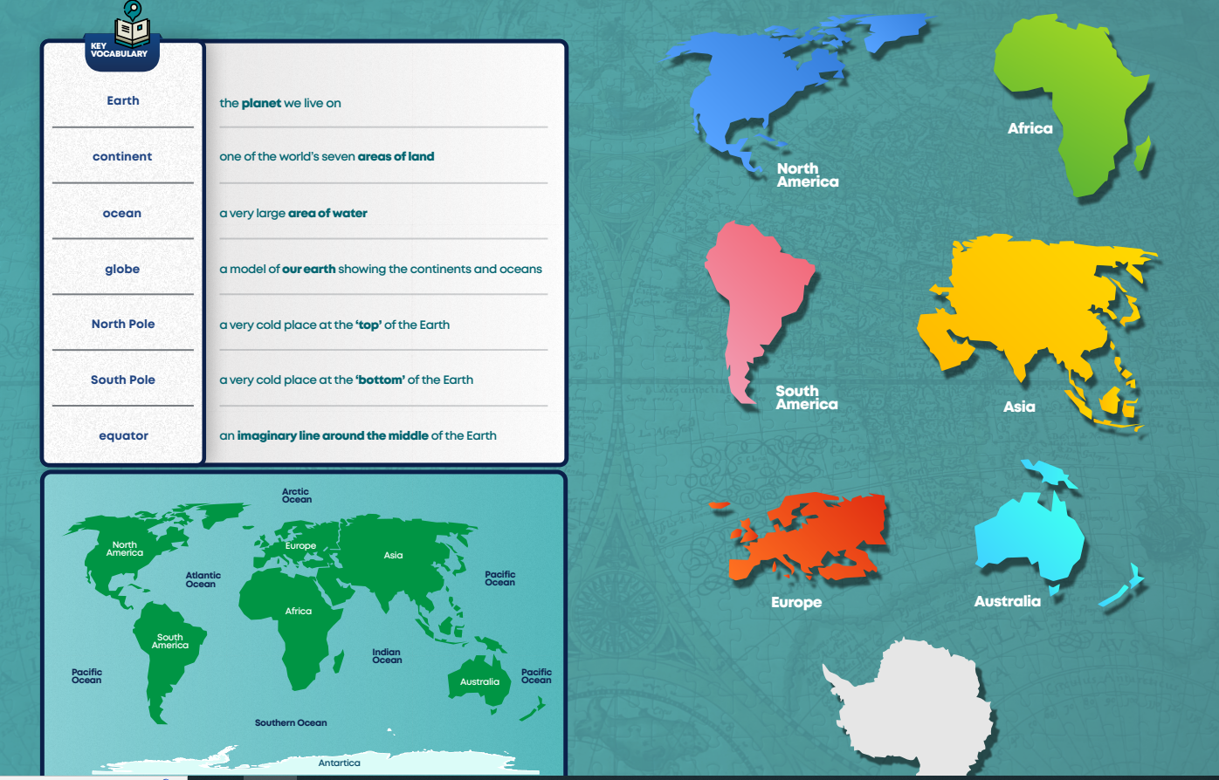
Art Knowledge Organiser

RE Knowledge Organiser
