Phonics |  | English |  | Maths
Children will continue to learn Phase 5 alternative sounds. Each week you will see exactly which sounds the children are learning on the phonics sheet with the weekly objectives on our website. . |  | In English, the children will be learning how to write a recount, focusing on key features such as using full stops, capital letters, and clear sequencing of events. We will then explore a poem together, looking at its structure and language, before writing our own rhyming poems. |  | Children will be building on their knowledge of place value to 20 and moving onto numbers to 50. They will also learn how to measure length, height, weight and volume
Science 1 | Science 2 |  | RE |  | Art and DT
Our first topic this half term is ‘Plants’. The children will be learning what plants need to survive, the difference between evergreen and deciduous trees and carrying out a cress growing experiment. Please see the knowledge organiser below. | Our second topic this half term is ‘How to look after the Earth’. The children will be exploring ‘reduce, reuse, recycle’, logging, renewable energy and pollution. Please see the knowledge organiser below. |  | Our topic is ‘What do Christians learn from the stories of Jesus?’. The children will explore events in Jesus’s lifetime, consider stories from the Bible that tell us about Jesus, and learn some parables that Jesus told to teach early Christian followers about God. |  | Our art topic is ‘Style and Narrative’. Children will explore pointillism used by Seurat and short brushstrokes used by Van Gogh. Children will learn that art can tell a story. Please see the knowledge organiser below.
Music | PSHE |  | PE |  | Computing
This term we are using the Charanga programme to teach music lessons. We will continue to develop the children’s understanding of rhythm, pitch and tempo, and will begin to improvise our own music and play on the glockenspiel. | Children will explore their rights and how to respect and look after others. Including First Aid and how to look after money. |  | The children will be learning how to play netball and dance, and learning all of the skills needed to be successful. |  | Our topic is ‘Moving a Robot’, where the children will learn how to control a ‘Bee Bot’

Science Knowledge Organiser
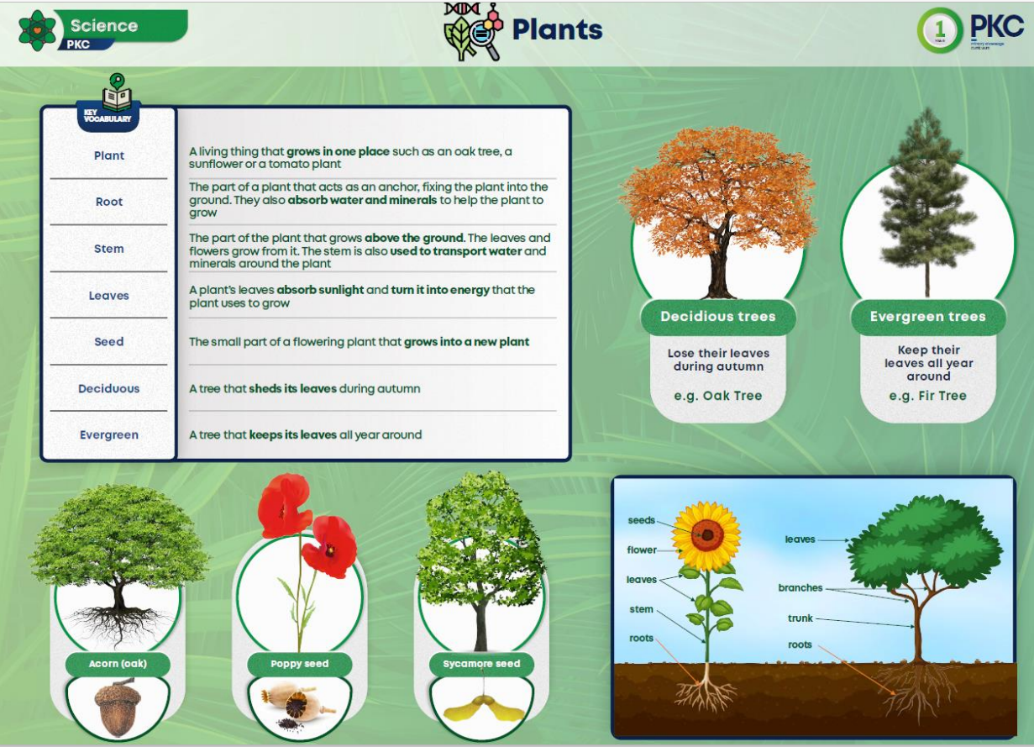

Science Knowledge organiser 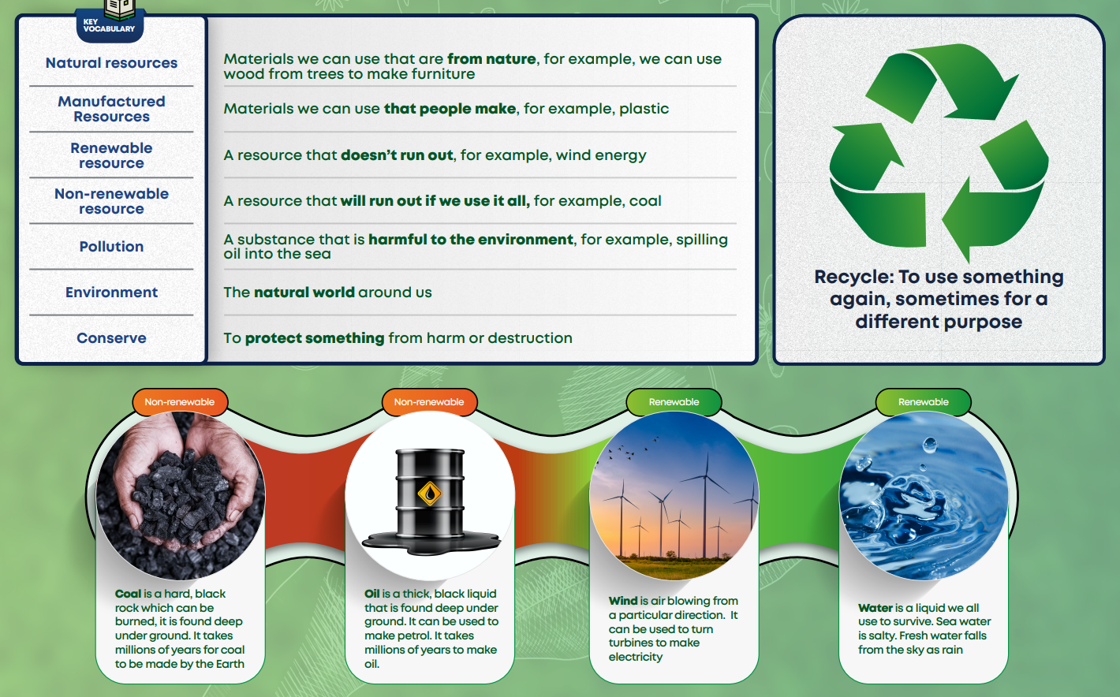

Art Knowledge Organiser
