Phonics |  | English |  | Maths
Children will recap the sounds required in their Phonics Screening Check. Please let your child’s class teacher know if you would like any guidance on how to support at home. |  | The children will be developing their writing skills by creating character descriptions, fact files and non-chronological reports. |  | Children will be developing their maths skills through practical activities and games. They will learn to tell the time to the hour and half past, looking at numbers from 50-100, recognise different turns and explore money through identifying coins and notes.
Science | History |  | RE |  | Art
Our Topic is Magnets and Materials’. The children will be learning about magnets and materials through a range of practical investigations and hands on activities. They will explore different materials and will learn about magnets and how magnets can attract and repel. Please see Knowledge Organiser below. | Our topic is called ‘Parliament, Prime Ministers’ and ‘Kings, Queens and leaders.’ Please see Knowledge Organisers below. |  | Our topic is Why people tell stories’. Children are learning the importance of storytelling and how stories can teach important lessons and values. Please see Knowledge Organiser below. |  | Our art topic is ‘Sculpture’, where the children will be exploring 3D art, moulding and casting. Please see the knowledge organiser below.
Music | PSHE |  | PE |  | Computing
We will continue to use the Charanga programme to teach music lessons. We will learn about songs to help us through the day, and continue to improvise music through these themed songs. | Children will learn about ‘Growing and Changing’. They will explore healthy eating and lifestyles, the importance of being themselves and ways to build self-esteem and resilience. The children will also learn about friendships, support networks and how to keep themselves safe. |  | The children will be practising their skills for the Summer Sports Day. |  | The children will be developing their computing skills through on-screen programming using Scratch Jr. they will investigate sprites and backgrounds while creating simple animations.

Science Knowledge Organiser
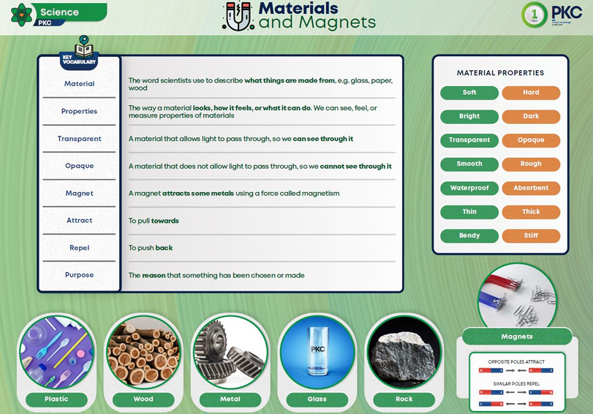

History Knowledge Organiser
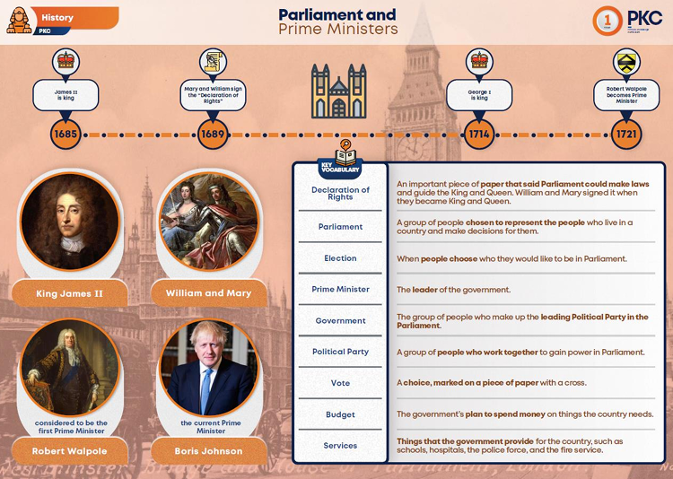

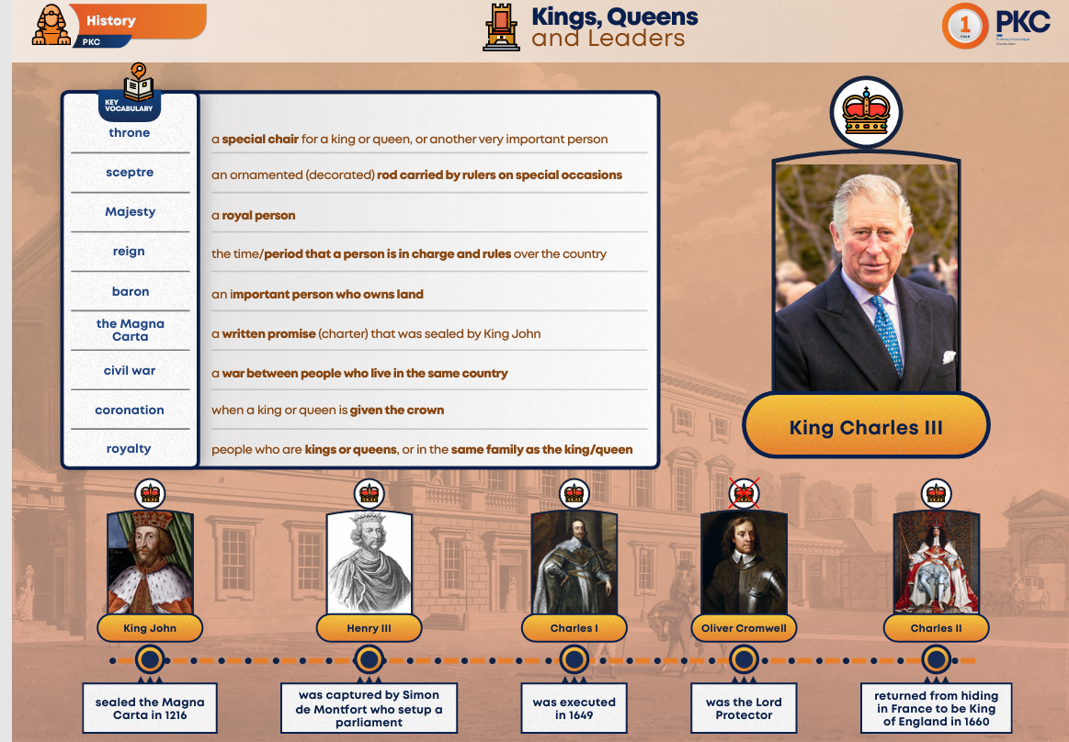
Art Knowledge Organiser
Art Knowledge Organiser

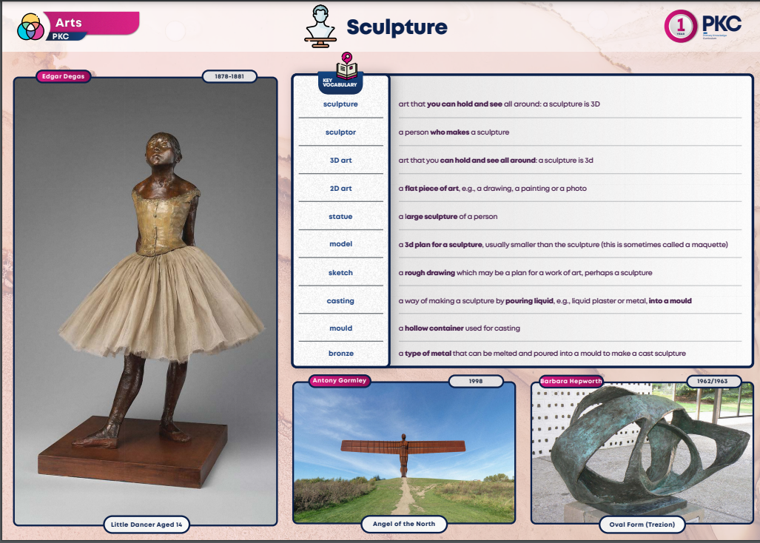

RE Knowledge Organiser
