Year 2 Learning Objectives

Spring Term w/b Monday 10th March

This week in school we will be learning…

English – to plan, write and edit our own 5-part story.

Maths – Compare mass. Measure in grams and kilograms.

Foundation learning

Science – to know that Earth travels around the Sun (orbit and rotation).

Computing – to recognise that objects can be represented by pictures.

PSHE – to explain and be able to use, strategies for dealing with impulsive behaviour.

PE – Netball – to show a range of actions to keep the ball under control. Gymnastics – to perform a range of actions with control and coordination.

Music – Inventing a musical story with recorder notes G, B, C, A

RE – Why do Christians call Jesus ‘Saviour’?

Spellings –

RULE: Why do I swap the ‘y’ for an ‘i’ when I add the suffix ‘-es’

\*Next page for practise words and dictation\*

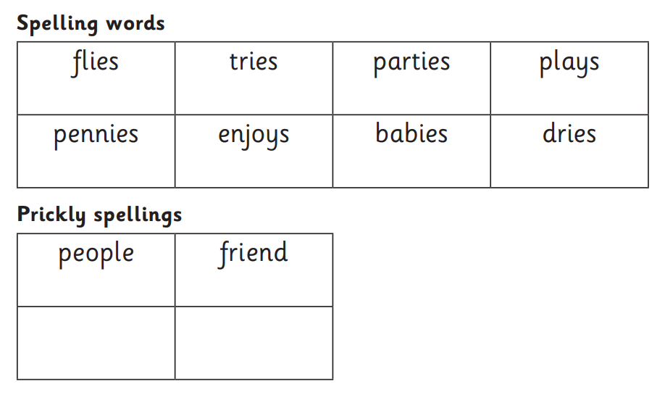

Dictation:

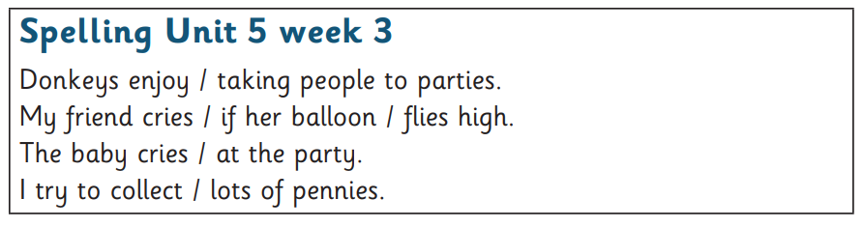

Additional homophone practise:

