Year 2 Learning Objectives

Spring Term w/b Monday 20th January

This week in school we will be learning…

English – To write our own setting description using the toolkit that we have been building.

Maths – Finding change, 2-step money problems. Equal groups and adding equal groups.

Foundation learning

Science – To know that scientists use microscopes to see very small things around us.

Computing – To use logical reasoning to predict the outcome of a program

## PSHE – To be able to identify situations in which they would need to say ‘yes', 'no’, ‘I’ll ask’ or ‘I’ll tell’ in relation to keeping themselves safe

PE – Controlling the hockey ball. Creating a dance sequence.

Music – To recap pitch through musical cartoon and learn and play the notes B, A and G together on the recorder.

RE – To know who Muhammad (PBUH) is to Muslim.

Spellings –

RULE: Why do I drop the e when I add the suffixes –ed, -ing, -er. -est, -y?

*Next page for practise words and dictation*

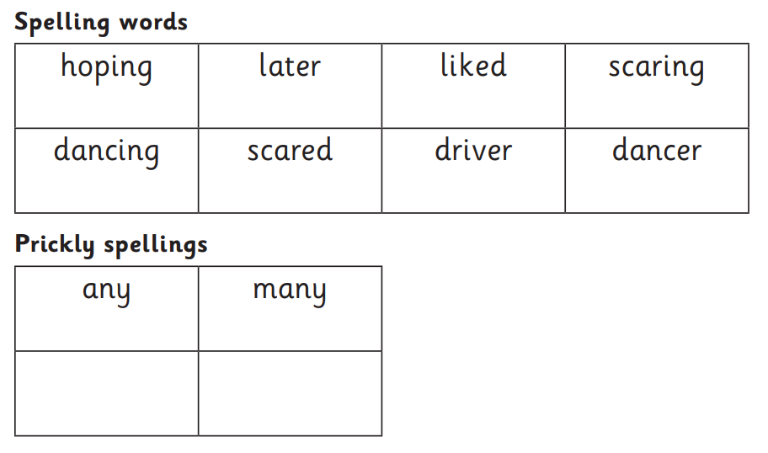

Dictation:

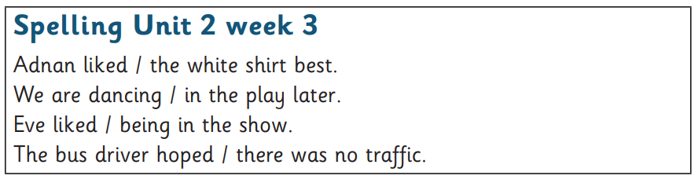

Additional homophone practise:

