Year 2 Learning Objectives

Spring Term w/b Monday 27th January

This week in school we will be learning…

English – To learn the features of a non-chronological report.

Maths – Introducing the multiplication symbol, writing addition as multiplication sentences, making and using arrays. * Next page for array examples *

Foundation learning

Science – To know that the shapes of solid objects made from some materials can be changed

Computing – To explain that programming projects can have code and artwork

## PSHE – To be able to recognise that body language and facial expression can give clues as to how comfortable and safe someone feels in a situation

PE – To dribble a ball with control whilst changing direction and speed and to be able to change actions when listening to music fast/slow/up/down.

Music – To recap tempo through musical cartoon and looking at rhythm grids.

RE – To understand why Muslim families want to follow Muhammad

Spellings –

RULE: Why do I drop the e when I add the suffixes –ed, -ing, -er, est and –y.

*Next page for practise words and dictation*

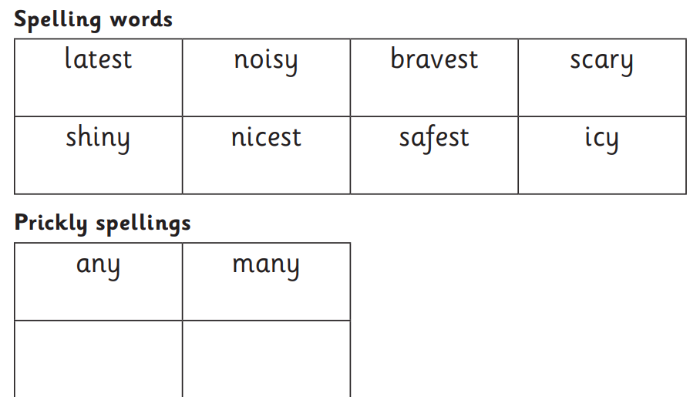

Dictation:

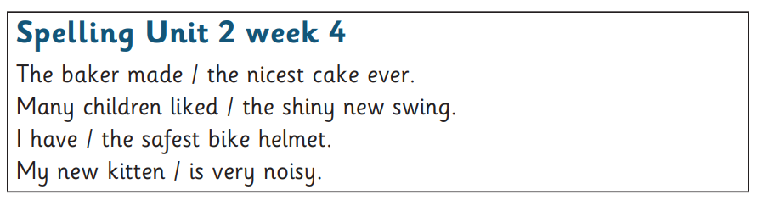

Multiplication Arrays

