Year 1 Learning Objectives Spring term w/c 19th January
This week in school we will be learning…

Maths - To understand 20. To understand 1 more and 1 less. To use a number line to 20.
English - To write the beginning of a story. To plan a story. To write a story.
Foundation learning
Geography - To know that Wales is one of the countries in the United Kingdom
Music – To listen, appraise and perform a song.
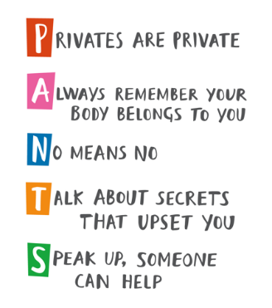
PSHE – This week is a really important part of our PSHE learning. The children will be learning about the PANTS rules.
- Name and know which parts should be private;
- Explain the difference between appropriate and inappropriate touch;
- Understand that they have the right to say “no” to unwanted touch;
- Start thinking about who they trust and who they can ask for help.

If you would like any more information then please speak to your child’s class teacher.
RE- . To know what Jewish families do to mark the start of Shabbat.
PE- To Perform basic gymnastic actions, including travelling, rolling, jumping and stay still and explore and link a range of movements and/or shapes
Computing – To identify that the look of text can be changed on a computer
Art – To be able to describe the different features of an important building
Science - To understand that scientists group animals according to their features.
Home Learning
1 – Please see the home learning matrix which has been sent out. Let your class teacher know if you require any more paper.
2 – Please see the attached sheet which includes our phonics learning for the week. Any extra spelling practice will help your child in their phonics lessons – spellings have been stuck into their spelling books or put into their book bags,
