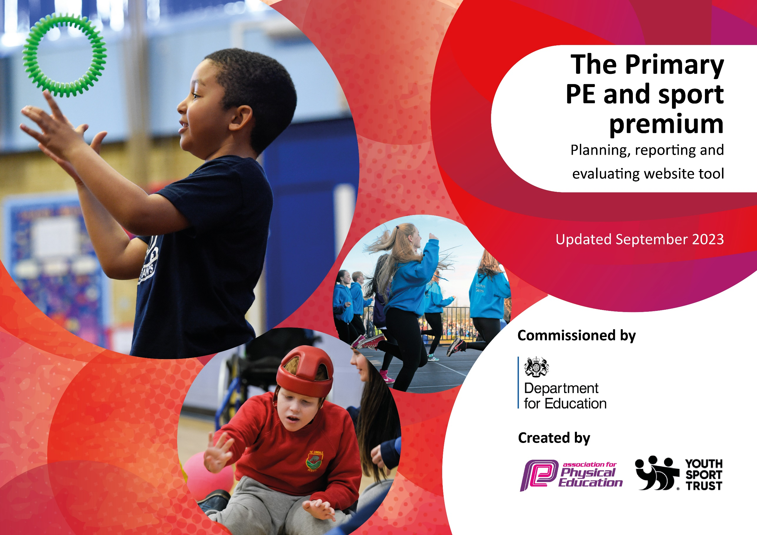

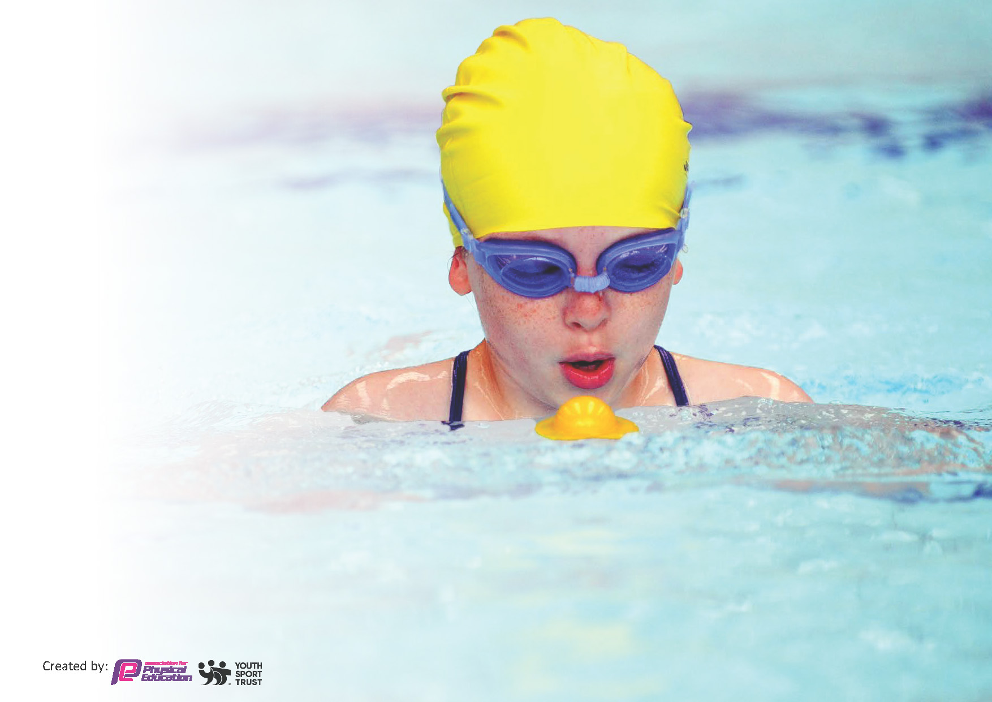
This template can be used for multiple purposes:
by:
- It enables schools to effectively plan their use of the Primary PE and sport premium
- It helps schools to meet the requirements (as set out in guidance) to publish information on their Primary PE and sport premium
- It will be an effective document to support Ofsted inspections enabling schools to evidence progress in Physical Education (PE) and evidence swimming attainment, which forms part of the PE National Curriculum. We would recommend schools consider
the Intent, Implementation and Impact of any spend, as examined within the Education Inspection Framework.

It is important that your grant is used effectively and based on school need.

Schools must use the funding to make additional and sustainable
improvements to the quality of the PE, School Sport and Physical Activity (PESSPA)
they offer. This means that you should use the Primary PE and sport premium to:

- Build capacity and capability within the school to ensure that improvements made now will benefit pupils joining the school in future years
- Develop or add to the PESSPA activities that your school already offers.

The Primary PE and sport premium should not be used to fund capital spend projects; the school’s core budget should fund these. Further detail on capital expenditure can be found in the updated Primary PE and sport premium guidance.

The Primary PE and sport premium guidance, outlines 5 key priorities that funding should be used towards. It is not

necessary that spending has to meet all the key priorities, you should select the priorities that you aim to use any funding towards.

Although completing this template is not a requirement for schools, schools are required to publish details of how they spend this funding. Schools must also outline what the impact this funding has had on pupils’ PE and sport participation and attainment and how any spending will be sustainable in the future. All funding must be spent by 31st July 2024.

The Department for Education has worked closely with the Association for Physical Education (afPE) and the Youth Sport Trust (YST) to develop this template and encourages schools to use it. This template is an effective way of meeting the reporting requirements of the Primary PE and sport premium.

This template will be completed at the end of the academic year and will showcase the key achievements schools have made with their Primary PE and sport premium spending.
Key achievements 2023-2024
Academic Year: 2024/25 | Total fund allocated: £17120 |  |  | Date Updated:
Key indicator 1: The engagement of all pupils in regular physical activity – Chief Medical Officer guidelines recommend that primary school children undertake at least 30 minutes of physical activity a day in school
School focus with clarity on intended impact on pupils: | Actions to achieve: |  |  | Funding allocated: | Funding Spent |  | Evidence, impact and sustainability:
To develop additional physical opportunities for pupils, particularly during playtimes, enabling more children to access equipment targeted at children’s core strength, balance and coordination.  To allow children to be active for 90% or more of PE lessons | Use of sports coaches during lunch and playtime to create sports and fitness opportunities.  Use Jump start Jonny as high quality video based content to utilise for in class warm ups and for high wind or very wet days – this will ensure the quality of provision is not compromised by poor weather. |  |  | £10,000  £250 | £10,000  £250 |  | Sport coaches now have lunch times and has great knowledge of every child's development and PE skills.  Continued use of this within most PE lessons as a warm up or in the case of bad weather. This is a high-quality way of getting children warmed up. It is also allowing children to be moving most of the lesson such as times where there is poor weather.
Totals |  |  |  | £10250 | £10250
Key indicator 2: The profile of Physical Education, School Sport and Physical Activity (PESSPA) being raised across the school as a tool for whole school improvement
School focus with clarity on intended impact on pupils: | Actions to achieve: |  |  | Funding allocated: | Funding Spent |  | Evidence, impact and sustainability:
To raise the profile of PE by inspiring children with real athletes visit  To invite masters in sports in to teach the children for a day. | Plan a day for Olympic athletes to come into school to inspire children with a whole school assembly and a PE lesson targeted for each class  Invite in a golf teacher and allow them to use the field as a putting ground and teach the children how to play golf. (Tri-golf) |  |  | £589  £500 | £0  £500 |  | As a team we decided to take a year off this due to higher priorities e.g. new sports equipment  Children had tri gold day which was very successful. All children accessed the learning and was especially good for SEND children
Totals |  |  |  | £500 | £500
Key indicator 3: Increased confidence, knowledge and skills of all staff in teaching PE and sport
School focus with clarity on intended impact on pupils: |  | Actions to achieve: | Funding  allocated: |  |  | Funding Spent
Implementation of Active Surrey to allow deeper staff training  Implication of sports style activities at lunch and break time allowing all staff to implement PE actives in this time |  | To use active Surrey for PE coaches and lead to undertake CPD including a specific gymnastics course  Purchase new and different equipment for children to access | £850  £3000 |  |  | £1250  £3000 |  | Gymnastics course planned for this academic year was cancelled so re-planned for next year. Active surrey allowed CPD for leaders and allowed us to get in touch with people such as the tri-golf day. PE lead also went on course about outdoor learning which has lead to a staff meeting and now more lessons are happening in the outdoor environment.  Children engagement in new activities has been high. Children are seen happy playing sports based games as well as ones they make up with the equipment. This has caused behaviour incidence to drop dramatically.
Totals |  |  | £3850 |  |  | £4250
Key indicator 4: Broader experience of a range of sports and activities offered to all pupils
School focus with clarity on intended impact on pupils: |  | Actions to achieve: | Funding  allocated: |  |  | Funding spent: |  | Evidence, Impact and Sustainability:
Offer a wide range of activities during curriculum and extracurricular time to encourage uptake of more pupils, encouragement of more activity.  Subsidise new external clubs to encourage increased participation. |  | Review of clubs – questionnaire parents and children.  Purchase equipment needed for new activities in order to sustain quality equipment for extra provision (basketball hoops/ tennis balls/ beanbags). | £666 |  |  | £666 |  | Children have loved the clubs over the year. We have seen full sports clubs across every sport and year group. Children love the opportunity to showcase what they have learnt.
Totals |  |  | £666 |  |  | £666
Key indicator 5: Increased participation in competitive sport
School focus with clarity on intended  impact on pupils: |  | Actions to achieve: | Funding  allocated: |  |  | Funding Spent |  | Evidence, Impact and Sustainability:
For pupils to experience intra-school competition, while using high quality equipment allowing them to show their full potential  Children to share sporting achievements in assembly – certificates where they achieved 1st, 2nd or 3rd |  | Purchase new equipment such as hurdles and tunnels.  Email out to parents, children informed, time made | £100  £0 |  |  | £1454  £0 |  | Money spent to deliver high quality sports day with gazeboes, sound system and obstacle course race.  Children are very proud of their achievements and are able to celebrate them with the whole school.
Totals |  |  | £100 |  |  | £1200
Total |  |  | £17,120 |  |  | £17,120

