Year 1 Home Learning Matrix Spring 2
Please see the suggested activities below for you to complete with your child at your leisure. Children are welcome to bring in completed homework at any time.

Science  Go on a plant hunt perhaps in your garden or for a walk in the local area. Look out for seeds and different plants and flowers. Can you name any? Can you spot deciduous or evergreen trees? You could take some photos.  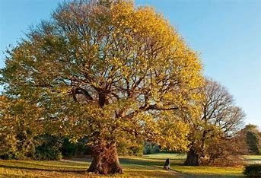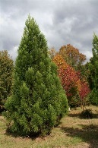 | Art  Can you create your own piece of art using the pointillism technique learnt in class?  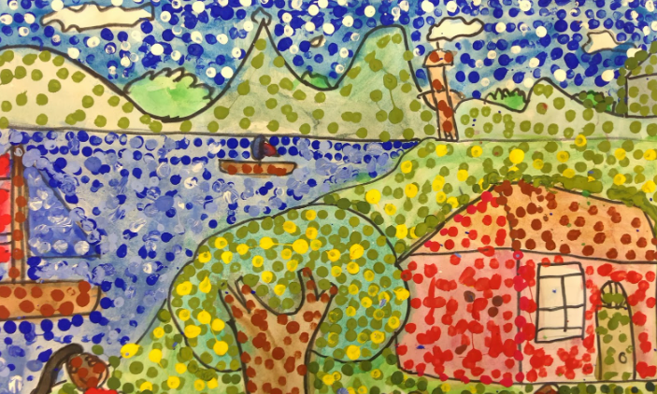
Maths  Use tens frames and number lines to practise addition and subtraction to 20.  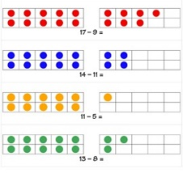  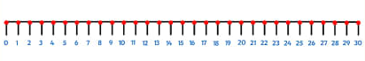 | Handwriting  Using the handwriting book provided, practise writing the following tricky words on the handwriting lines.  many again  who whole  school different  thought through  friend work
English  Write a recount about something new that you have done. For example – you may have visited somewhere new, or started a new hobby. Remember to recount the events in time order, using the past tense and including interesting details. Good luck! | PSHE  Make a poster to show ways to keep yourself safe. E.g. crossing the road, keeping safe online  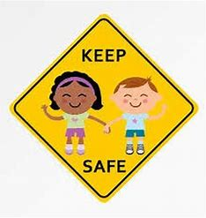
Music  Listen to some of these songs. Can you learn any of them?  Primary School Songs: Songs about school - BBC Teach | RE  Design an Easter card. Can you include some of the symbols that represent Easter?  