Year 1 Learning Objectives Summer term W.C. 11th May
This week in school we will be learning…

Maths - Add equal groups, add arrays, double numbers to 20.
English - plan a narrative, write a narrative, learn a text map, know features of instructions.

Foundation learning
Music – To listen, appraise and perform a song.
PSHE - To recognise the importance of hygiene routines. To understand how diseases spread.
ICT – To plan a simple program
RE - To know that the Torah is important to Jewish people.
PE- To show understanding of the correct running technique.
Geography – To recognise Europe as one of the world’s seven continents.
Science - To know that there are different types of cloud.

Home Learning
1 – Please see the home learning matrix which has been sent out. Let your class teacher know if you require any more paper.
2 – Please see the attached sheet which includes our phonics learning for the week. Any extra spelling practice will help your child in their phonics lessons – spellings have been stuck into their spelling books or put into their book bags

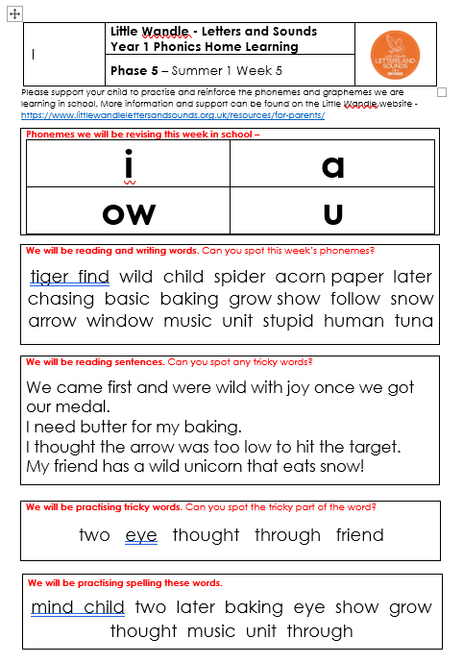
Ye

