Year 1 Learning Objectives Summer term W.C. 18th May
This week in school we will be learning…

Maths – To be able to share an amount equally. To be able to half a shape.
English - Write a sentence with a verb and adverb. Plan a set of instructions. Write a set of instructions.

Foundation learning
Music – To listen, appraise and perform a song.
ICT – To find more than one solution to a problem
Geography – To explain our own knowledge about the world we live in.
Science - To understand that a weather forecast helps people prepare for different types of weather.

Home Learning
1 – Please see the home learning matrix which has been sent out. Let your class teacher know if you require any more paper.
2 – Please see the attached sheet which includes our phonics learning for the week. Any extra spelling practice will help your child in their phonics lessons – spellings have been stuck into their spelling books or put into their book bags

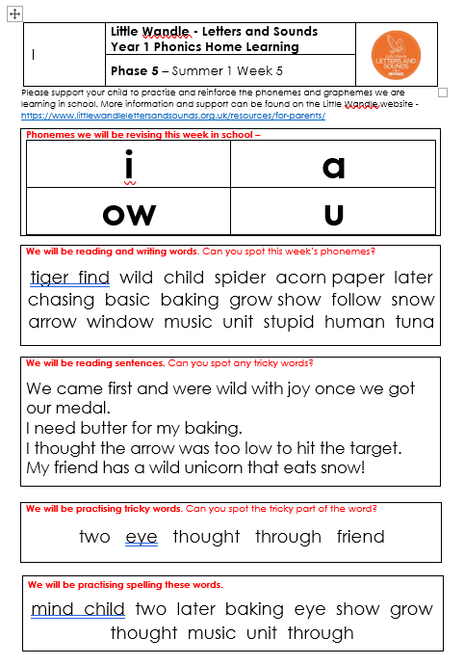
Ye

