Year 1 Home Learning Matrix Summer 2
Science  We are learning about magnets. Can you make a list of things in your house that are magnetic?  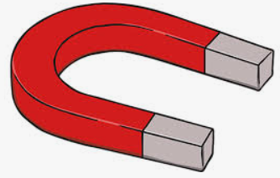 | History  Can you create a factfile about a King or Queen?  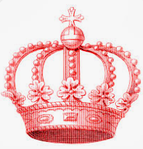
Maths  Can you practice giving directions to somebody, thinking about forwards, backwards, left, right, turn (full turn, half turn, quarter turn)?  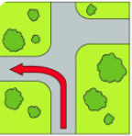 | Handwriting  Using the handwriting paper provided, can you practice writing the days of the week? You could also challenge yourself to try writing the months of the year!  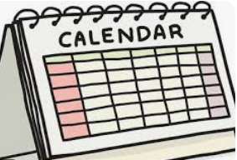
English  We are learning about narratives. Can you write a story about something that happens to your family?  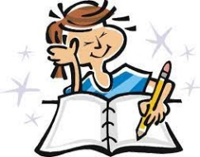 | PSHE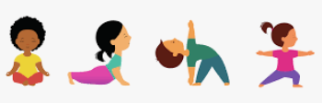  Can you think of ways that you can keep your body healthy? What do you need to do from the outside, and what do you need from the inside of your body?
Music  We are learning about performing, with singing and dancing together. Can you sing some songs with actions with your family?  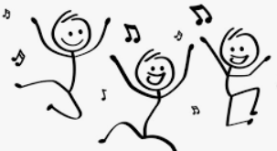 | RE    We are learning about stories and what we can learn from them. Can you write about a story that you learned something from?
Please see the suggested activities below for you to complete with your child at your leisure. Children are welcome to bring in completed homework at any time.

